MATHEMATICS DEPARTMENT 2015
Year 11 Specialist - Test Number 6
Resource Free
Transformations and Trigonometric Functions



Name: ______Solutions_________________________ Teacher: DDA
Marks: 28
Time Allowed: 25 minutes
Instructions: You are permitted no notes or calculators.
_________________________________________________________________________
8multiple-choice questions
1 mark each: 8 marks
Circle the correct answer.
1 What is the matrix for the translation of A(2, 5) B(–3, 3) Aʹ(4, 3) Bʹ(–1, 1)?
A
B
C
D
E

[1 mark]
2 What is the transformation for the matrix?
A (x, y) (2y – 3x, 2x – y)
B (x, y) (3x – 2y, 2x – y)
C (x, y) (2y – 2x, 3x – y)
D (x, y) (3y – 2x, 2x – y)
E (x, y) (2x – 2y, 3x – y)

[1 mark]

3 What is the image of the triangle A(6, 4) B(2, 6) C(8, 12) under the dilation with factor 0.5 in the x-direction and 2 in the y-direction?
A Aʹ(12, 8) Bʹ(4, 12) Cʹ(16, 24)
B Aʹ(12, 2) Bʹ(4, 3) Cʹ(16, 6)
C Aʹ(3, 8) Bʹ(1, 12) Cʹ(4, 24)
D Aʹ(3, 2) Bʹ(1, 3) Cʹ(4, 6)
E Aʹ(3, –8) Bʹ(1, –12) Cʹ(4, –24)

[1 mark]
4 What is the matrix for a rotation of ?
A
B
C
D
E

[1 mark]
5 The amplitude of the graph y = –3 sin is:
A 2
B –2
C 3
D –3
E 4
[1 mark]

6 The period of the graph y = 5 sin is:
A π
B
C 2π
D
E

[1 mark]
7 The amplitude, period and phase shift of the graph y = 2 sin are respectively:
A 2, π, horizontally to the left
B –2, π, horizontally to the right
C π, 2, horizontally to the left
D 2, 2π, horizontally to the left
E 2, 2π, horizontally to the right

[1 mark]
8 The period and phase shift of the graph y = 2 cos (4x – π) are respectively:
A 4π, π horizontally to the left
B , horizontally to the right
C , horizontally to the left
D , π horizontally to the right
E , π horizontally to the left

[1 mark]

4 short answer questions
20 marks
Show your working where appropriate.
9 T1 is a reflection in the line through the origin with inclination .
T2 is a reflection in the line through the origin with inclination .
a Find $T_{1}$
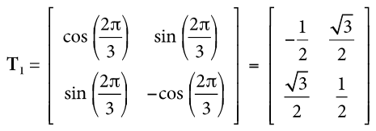

b Find $T_{2}$
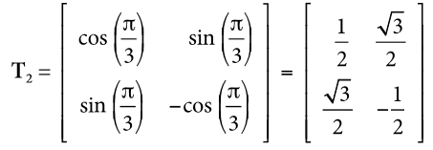

c Express the transformation T1 T2 as a matrix.
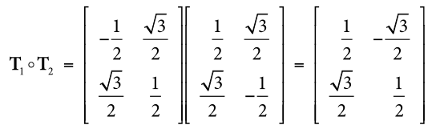
$$\left[\begin{matrix}-\frac{1}{4}+\frac{3}{4} & -\frac{\sqrt{3}}{4}-\frac{\sqrt{3}}{4} \\ \frac{\sqrt{3}}{4}+\frac{\sqrt{3}}{4} & \frac{3}{4}-\frac{1}{4}\end{matrix}\right]$$

d What kind of transformation is T1 T2?
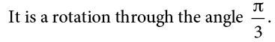

[2,2,2,2: 8 marks]

10 The transformation T is represented by the matrix $\left[\begin{matrix}1 & 0 \\ 0 & -1\end{matrix}\right]$
- Describe in words the transformation T.
Reflection across the x-axis
- The transformation T is applied to the line with equation $y=x$. Find the equation of the resulting line.
y = - x
- The point A is mapped to the point with coordinates (k, k + 1) under transformation T. Find the coordinates of the point A.
(k, -k-1)
- What is the transformation matrix for dilation of factor 3 in the x-direction?
$\left[\begin{matrix}3 & 0 \\ 0 & 1\end{matrix}\right]$

[4 marks]
11 For the function below, answer the following questions for 0 ≤ x ≤ 2 π.
 | What is the maximum value? | For what value(s) of x does the maximum occur? | What is the minimum value? | For what value(s) of x does the minimum occur?
y = –1 – 4 cos (x – π) | 3 | 0, 2$π$ | -5 | $$π$$
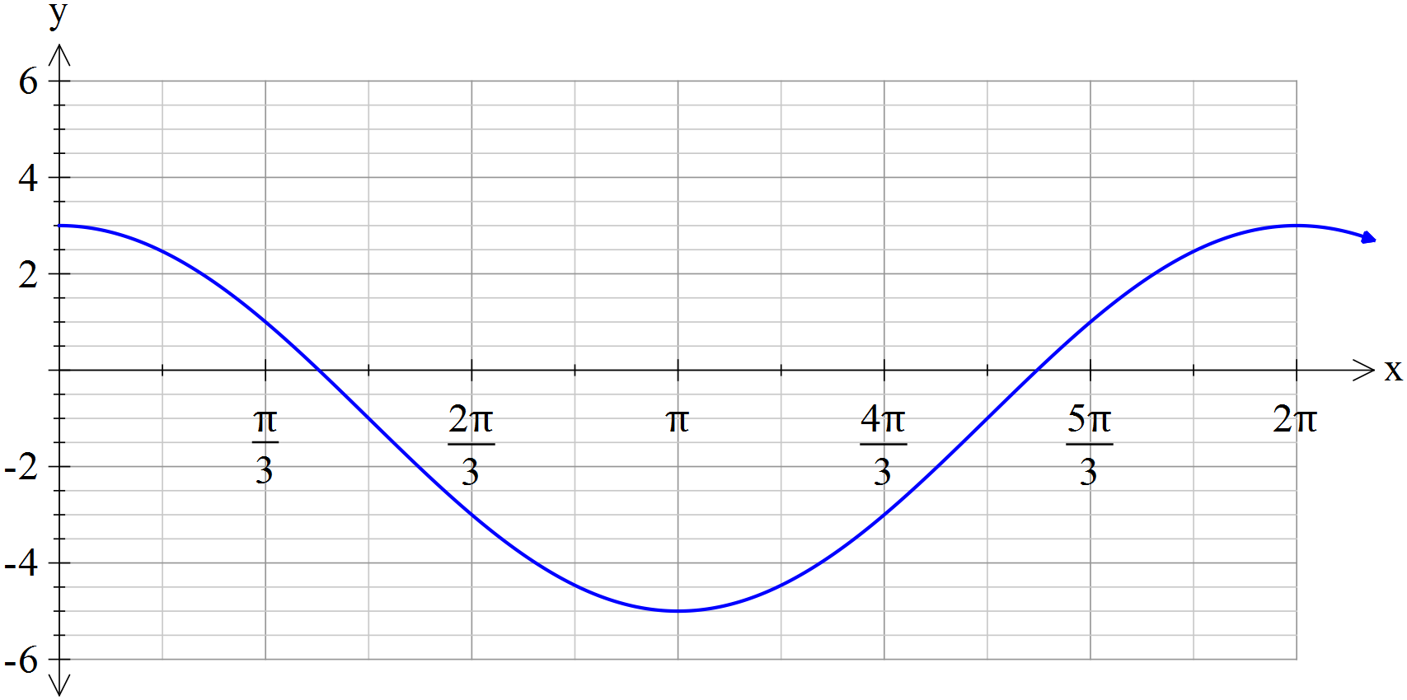

[4 marks]

12 Solve for all values of$θ: tan \left(2θ+\frac{π}{6}\right)=-1$.
$$2θ+\frac{π}{6}=\frac{3π}{4}±nπ$$
$$2θ=\frac{3π}{4}-\frac{π}{6}±nπ$$
$$2θ=\frac{7π}{12}±nπ$$
$$θ=\frac{7π}{24}±\frac{nπ}{2}$$

[4 marks]

MATHEMATICS DEPARTMENT 2015
Year 11 Specialist - Test Number 6
Resource Rich
Transformations and Trigonometric Functions



Name: ______Solutions_________________________ Teacher: DDA
Marks: 20
Time Allowed: 20 minutes
Instructions: You are permitted 1 A4 page of notes and your calculators. Show your working where appropriate.
_________________________________________________________________________
13 Using a calculator, solve the equation = 1 for 0 ≤ x ≤ π.
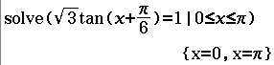
[1 mark]
14 Given transformation matrix T = $\left[\begin{matrix}4 & -3 \\ 1 & 5\end{matrix}\right]$
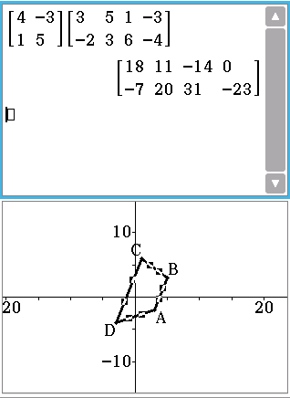
a Find the image of the trapezium A(3, –2) B(5, 3) C(1, 6) D(–3, –4) under the transformation T.
A’= (18,-7)
B’= (11,20)
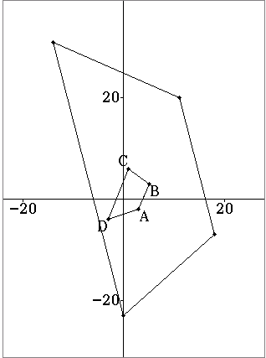
C’= (-14, 31)
D’= (0, -23)
c What shape is the image?
A trapezium

[4,1: 5 marks]

15 The area of the triangle ABC is 27.5 cm². Find the area of the image of the triangle ABC after the transformation T: (x, y) $→$ (4x – y, 2x + 5y).
Area (Image) = |det| x Area (Original)
|det T| = |$\left[\begin{matrix}4 & -1 \\ 2 & 5\end{matrix}\right]$| = 20 - -2 = 22
Area (Image) = 22 x 27.5
= 605 cm²
[3 marks]
16 The displacement of a particle is given by x = 3 sin (2t) + cos (2t).
a Express the displacement in the form x = r sin (2t + $α$) giving r in exact form and $α$ to 2 decimal places and in radians.
$$3\sin{2t}+\cos{2t}=rsin (2t+α)$$
$$∴3\sin{2t}+\cos{2t}=rsin 2t\cos{α+}r\cos{2t}\sin{α}$$
$$∴3=r\cos{α} 1=r\sin{α}$$
$$1$$
$∴r=\sqrt{10} α=\tan^{-1}\left(\frac{1}{3}\right)≈0.32$
$$3$$
$$r$$
$$α$$
$$∴3\sin{2t}+\cos{2t}≈\sqrt{10}sin (2t+0.32)$$
[5 marks]

b Hence find the greatest distance that this motion reaches from the mean point.
$$\sqrt{10}$$

[1 mark]

17 The time between successive high tides at a pier is 12 h 34 min. The average depth of water is 4 m, but at low tide it is 3.1 m. The tide can be modelled by $y=a\cos\left(x-1\right)+b$
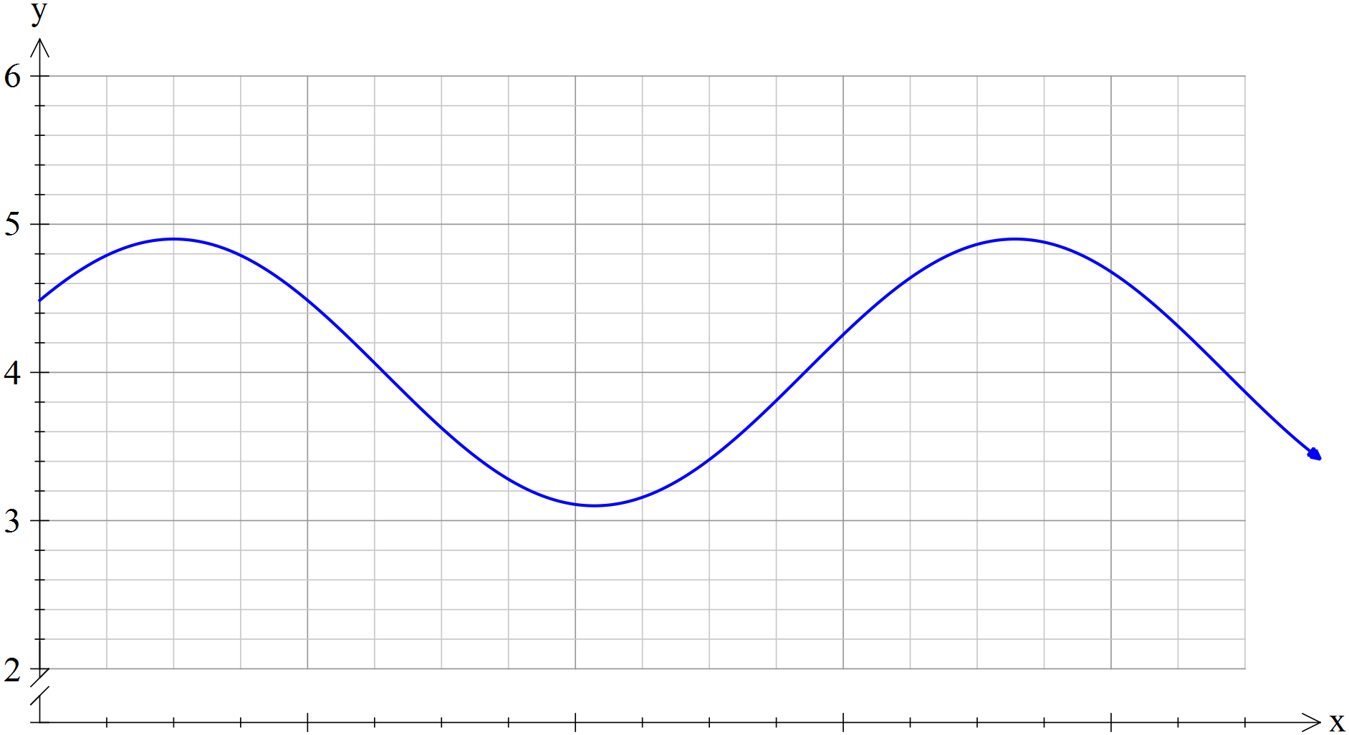

- Determine the values of $a$ and $b$ in the equation.
$$y=0.9\cos\left(x-1\right)+4$$
a = 0.9
b = 4
- Find the length of time that a boat can use the pier if it is only able to dock when the tide is between 3.5 and 4.5 metres.

$y=3.5, x=3.1598273…$
$$y=4.5, x=1.9817654…$$
$$∴∆x≈1.178$$
Once cycle is 2$π≈6.283$
Proportion of cycle where boat can dock is $\frac{2×1.178}{6.283}≈0.375$
$∴$Boat can dock for 0.375 x 12 hrs 34 mins = 0.375 x 12.5$\dot{6}$
= 4.7125 hours = 4 hours 43 minutes

[2,3: 5 marks]
Or
Each cycle is 12.56 hr which is 2 x 2$π$

So Double the portion of the cycle to convert to time
1.178 x 2 = 2.356 hours

Double for the two sections of the cycle which fit the time frame

- 4.712 hours
- 4 hours 43 minutes

